**7 DAYS GORILLAS, BIG FIVE AND LAKE MBURO**

Gorillas, Wildlife Safari and Kazinga Cruise

Bwindi Impenetrable Forest National Park and Queen Elizabeth National Park are most visited in Uganda by tourist among other destinations. Bwindi Impenetrable Forest National Park is entirely covered by dense forest with thick different species of natural vegetation and different melodies of different birds and Bamboo trees which is sweet to the Mountain Gorillas. Queen Elizabeth National Park has a diverse ecosystem which include a sprawling savanna, sparkling lakes, humid forests, fertile wetlands which makes it a suitable home for over 600 species of birds, outstanding wildlife attractions like tree climbing lions, chimpanzees among others. The Park is set against the beautiful sceneries of the Rwenzori Mountains, the panoramic view of kazinga channel. The park was founded in 1952 and was named the kazinga National Park and in two years it was renamed as Queen Elizabeth National Park after the visit of Queen Elizabeth 2.Its located in Kasese, approaching the park from the south via Mbarara covers the distance of 420km while the north through Fort Portal covers the distance of 410km.

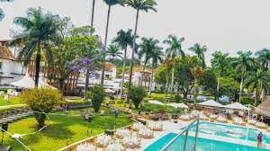

**ITINENARY**

**DAY 1: ARRIVAL AT ENTEBBE INTERNATIONAL AIRPORT**

You will be welcomed by a representative of **FRIENDS NATURE SAFARIS** If you arrived at the airport early we may just drive to Lake Mburo National Park its about 4 hour drive from Kampala-Masaka main road we shall have a stopover at the Equator for lunch and photo shoots then continue with our journey to Lake Mburo.Upon arrival we check in at our lodge, then we do a boat cruise on Lake Mburo when back have evening at leisure. Dinner and overnight stay at Mihingo Safari Lodge (Any Equivalent)

**DAY 2: KAMPALA – BWINDI IMPENETRABLE NATIONAL PARK**

Early morning we shall do safari walk around the park to see animals like Giraffes, Kobs, Zebras and many more, breakfast then leave for Bwind Impenetrable National Park .We shall drive via a scenic route, savanna vegetation and Ankole cattle and precede our drive through the green growth countryside, we shall have lunch on the way and final we arrive in Bwindi and check in at our Lodge for dinner and overnight at Silver Back Lodge Luxury (Any Equivalent).

[**DAY 3: BWINDI IMPENETRABLE FOREST NATIONAL PARK**](http://www.friendsnaturesafaris.net)

In the morning we take our breakfast and assemble for briefing according to the group which we are going to trek/track about the does and donots.This activity is one of highlight of our safari, meeting with the gentle giants of Bwindi, Especially hikers will love the gorilla trekking in the beautiful ecosystem of the park. It is difficult to foresee how many hours you will hike, it may take two to eight hours. Expect to walk a long distance in steep and muddy conditions, sometimes with rain overhead, before you encounter any gorillas. But we found these creatures it is very rewarding and interesting as you observe them closely while they eat, play and rest. A unique and unforgettable experience! For conservation purposes, time spent with the gorillas is limited to one hour. The ranger guide always briefs you on how to behave with these giant apes. After the trek we return back to lodge for lunch and evening at leisure. Dinner and overnight at Silver Back Lodge Luxury (Any Equivalent).

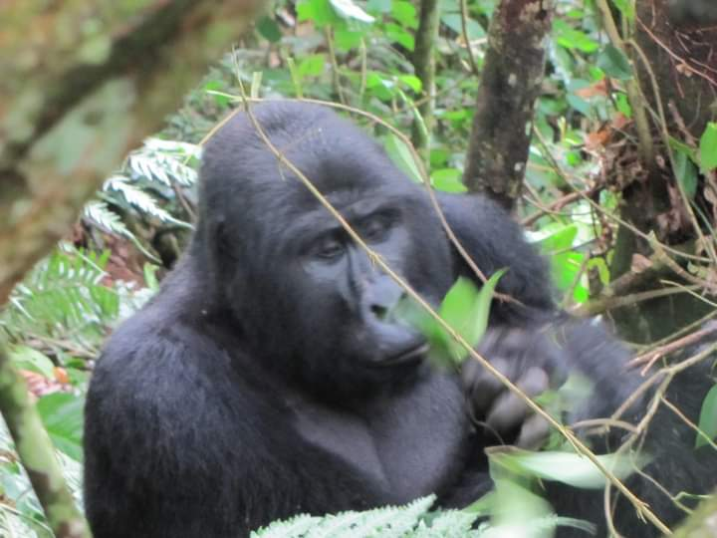

**DAY 4: BWINDI IMPENETRABLE TO QUEEN ELIZABETH NATIONAL PARK**

After breakfast you can choose to have a guided village walk for a closer meeting with the local community. Learn about their way of living as you walk through coffee, tea and banana plantations. Afterwards we depart to Queen Elizabeth National Park. We will pass the southern sector of the park, called Ishasha and known for the tree-climbing lions and here we expect to see some of the lions resting on the branches of trees. While we continue to our accommodation in the middle of the national park be alert to spot some wildlife like kobs, waterbucks and warthogs while grazing. Dinner and overnight at Mweya Safari Lodge Luxury (Any Equivalent)

**DAY 5: QUEEN ELIZABETH NATIONAL PARK**

After our early morning breakfast we start our game drive around Mweya Peninsular if we slept around that area then after we head for the mating ground of the Uganda kobs. We search for Lions, Elephants, Buffaloes and other wild animals in their natural habitat, return back to lodge for lunch. In the afternoon we take on a boat cruise along the Kazinga Channel, a natural channel between Lake Edward and Lake George we shall see animals like Elephants, Buffaloes, hundreds of Hippos this channel is also known as a birders haven, snacks and soft drinks will be served while on the cruise, this cruise will definitely be another highlight of our safari. Dinner and overnight at Mweya Safari Lodge Luxury (Any Equivalent).

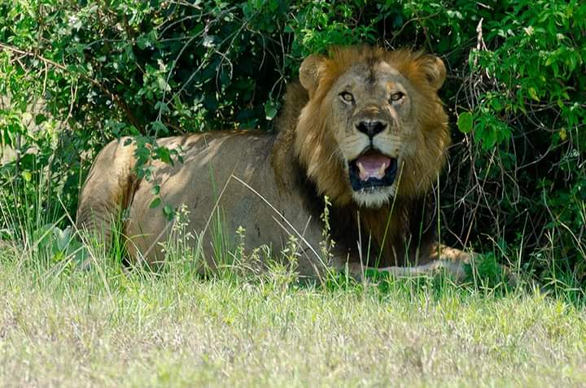

**DAY 6: QUEEN ELIZABETH NATIONAL PARK TO KAMPALA**

Warm wake up and then we take breakfast, we pack our belongs and embark on our Safari van and leave the park for Kampala, we shall do a game drive in the park as we are getting out, we shall have lunch on the way and a stopover at Mpambire Drum Makers to buy souvenir to take home. Finally we arrive in Kampala City. Dinner and overnight at Serena Hotel Kigo Luxury (Any Equivalent)

**DAY 7: KAMPALA TO AIRPORT**

Enriched with an experience of a lifetime and unforgettable memories you will say goodbye to the Pearl of Africa. Depending on the time of departure you will be transferred to the airport for your flight back home. We are looking forward to seeing you again.

STARTS FROM 3573 USD EACH FOR 2 PEOPLE